Binary Tree Level Traversal - Solution
Report Issue

We provide C++ and Java codes for your reference.
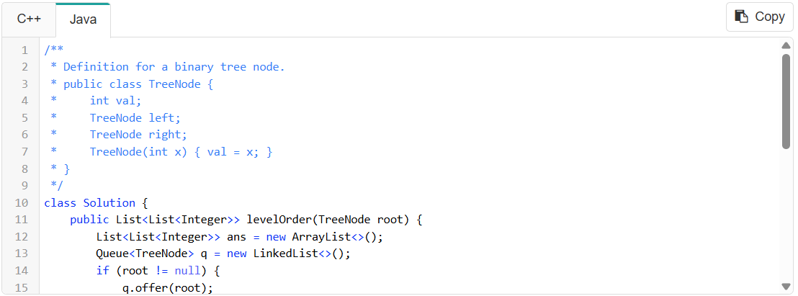
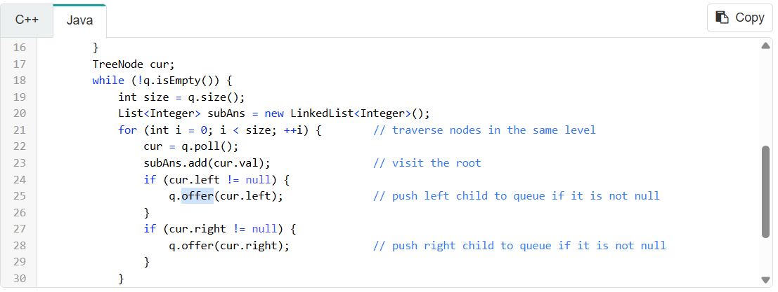
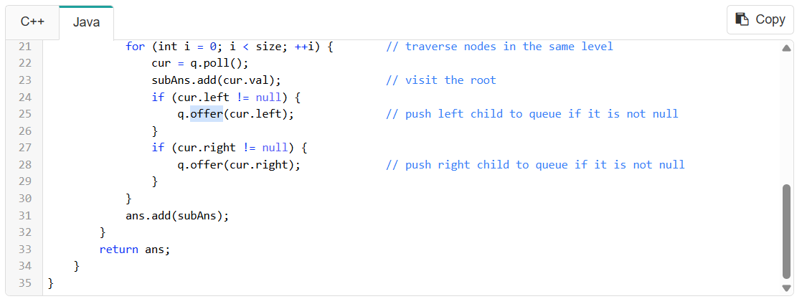
Since each node in the tree will be pushed into the queue exactly once, the time complexity for level-order traversal is O(N), where N is the total number of nodes in the tree.
What about the space complexity? We need to maintain a queue to assist with the traversal. The maximum size of the queue will be determined by the number of nodes at the deepest level of the tree. In the worst case, the queue can hold up to `N/2` nodes (where `N` is the total number of nodes), which is still $O(N)$. Therefore, the space complexity of level-order traversal is also $O(N)$.

